Fresh water has always been a limited resource in some parts of the world. Today, however, growing worldwide demand has made this a global program.

What are the causes of the increased demand and what measures can governments and individuals take to respond to this problem?

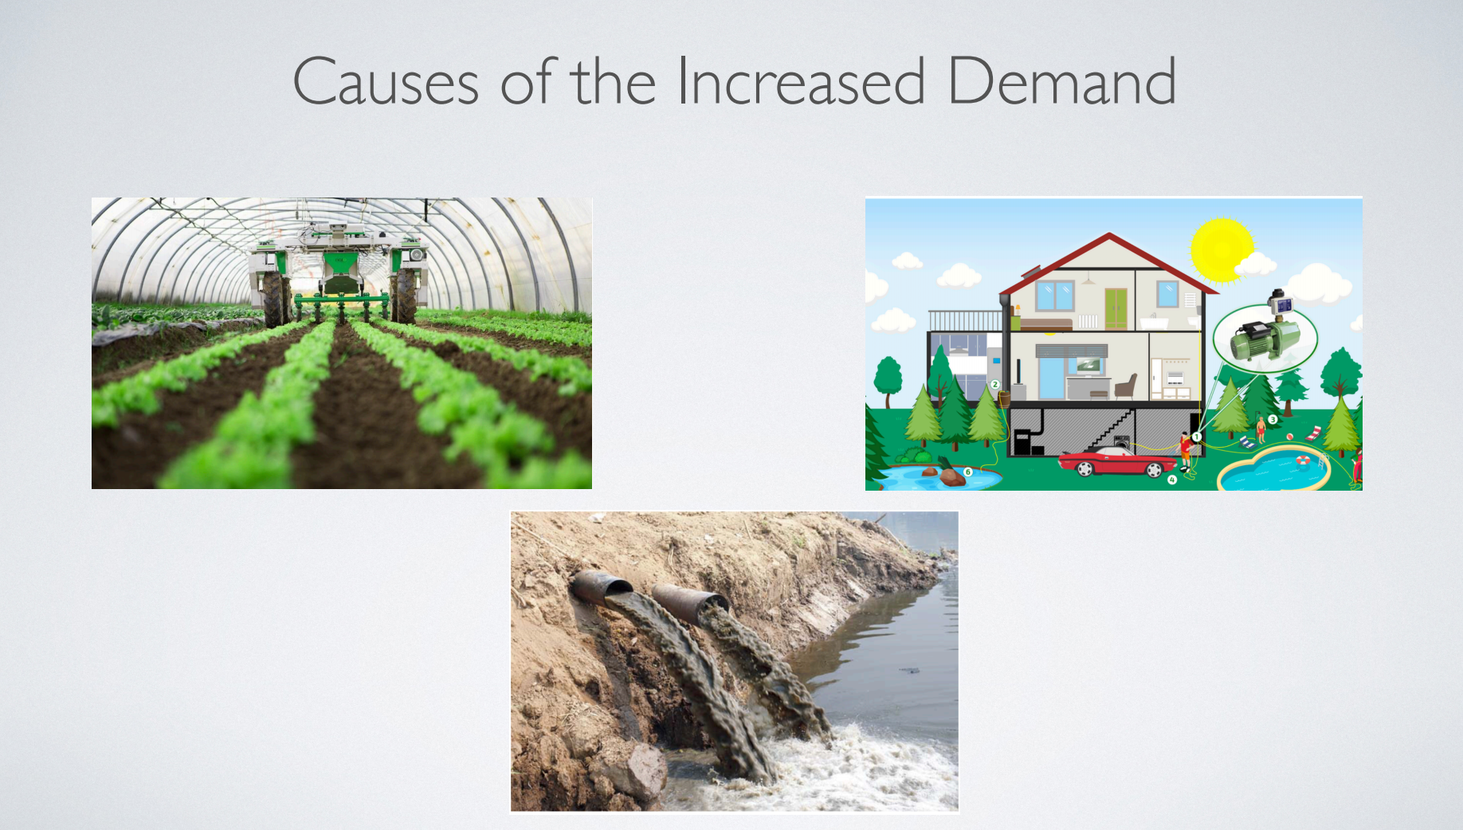
Causes of the increased demand:
Agricultural demand: growing population → expanding agricultural sector → rising water consumption;
Domestic demand: growing population → drinking, bathing, cooking → water shortages

【开头段】①由于对淡水的需求不断增加，水资源短缺已成为许多国家的一个紧迫问题。②必须分析这种需求激增的原因，并探讨政府和公众成员为解决这一问题可以采取的战略。

① Due to the increasing demand for freshwater, water scarcity has become a pressing issue for many countries. ②It is essential to analyze the reasons for this surging demand and explore possible strategies that governments and public members can adopt to tackle this matter.

【BP1】①世界各国对淡水的迫切需求有两大因素。②第一个因素与农业需求有关。③随着世界人口的迅速增长，各国政府纷纷扩大农业部门，以满足对粮食的巨大需求。④由此导致了用水量的急剧增加。⑤以泰国为例，农业用水量已占淡水总用量的三分之一。⑥第二个因素是家庭用水量不断增加。⑦人口增加意味着日常活动如饮水、洗澡、浇灌草坪和花园、维护游泳池等需要使用更多的水，加剧了许多地区的缺水状况。

①There are two major factors contributing to the burning desire for freshwater across the world. ②The first relates to agricultural demand. ③With the world population growing rapidly, governments are expanding their agricultural sectors to meet the enormous demand for food. ④This has consequently resulted in a drastic increase in water consumption. ⑤For instance, in Thailand, agriculture has accounted for a third of the total use of freshwater. ⑥The second factor is the growing domestic water use. ⑦Larger populations mean that more water is used for daily activities such as drinking, bathing, watering lawns and gardens and maintaining pools, exacerbating water shortages in many regions.

【BP2】①缓解这些地区的水危机，决策者和公民都需要采取切实可行的办法。②具体来说，当局应该加大投资，开发技术，提高灌溉效率，减少不必要的浪费。③此外，政府还可以为生物工程项目提供更多的资金，帮助创造出可以用更少的水生长的新作物。④以色列是一个突出的例子，它已经成功地培育出了可以在沙漠中生长的蔬菜。对于个人来说，要多关注家庭用水，让每一滴水都有价值。⑤例如，他们可以把用过的水节省下来，用于冲厕所等其他用途。

①To mitigate water crises in these areas, both policymakers and citizens need to take practical approaches. ②To be specific, the authorities should invest more in developing technology to improve irrigation efficiency, cutting down on unnecessary waste. ③Also, governments can provide more funding to bio-engineering programs, helping create new crops that can grow with less water. ④Israel is a salient example, which has successfully bred vegetables that can thrive in deserts. ⑤As for individuals, they need to pay more attention to household water use, making every drop of water count. ⑥For example, they can save used water for other purposes such as flushing toilets.

【总结段】①综上所述，由于农业和国内需求的蓬勃发展，世界各地的淡水越来越少。②尽管这个问题很严重，但政府和个人可以采取行动来缓解。

① In summary, due to booming agricultural and domestic demand, freshwater is becoming increasingly scarce across the world. ②Despite the gravity of this problem, governments and individuals can take actions to alleviate it.

